Kindergarten Remote Learning Plans

March 30 – April 3

**Monday, March 30**

*ELA – 1. sight word *out* worksheet (2-sided), write & read sentences that contain new word

<https://www.youtube.com/watch?v=QxljqYxXyJA>

1. watch the video & practice CVC words - <https://www.youtube.com/watch?v=ii18uH36ySU>
2. CVC packet – choose 2 pages and complete

4. Journal Prompt – In your journal, write & respond to the prompt “This past weekend, I…”

*write 2-3 sentences – all sentences begin with an uppercase letter and end with punctuation

*finger spaces between words

*listen for beginning, middle and ending sounds in your words

*color a picture that represents your sentences

*Parents, let your child sound out words independently. It’s okay if it’s not spelling correctly. We’re

looking for beginning, middle and ending sounds of the words.

*Science –All materials can be found in the science packet.

1. Sing hand washing song – can you find any sight words or “sh” words?

2. “How to Wash my Hands” – read, cut & paste steps

*Special – recess

**Tuesday, March 31**

*Math – 1. To access online math video for lesson 6.3

Login with Tiger ID

Click “Think Central”

Click “My Library”

Click “Math on the Spot Video Tutorials”

Select “Grade K” 🡪 Chapter 6 Subtraction 🡪 Lesson 6.3

2. lesson 6.3 – pages 323-325, 327-328

*Science – 1. “How to Wash my Hands” First, next, then, last – finish the steps with a sentence, draw a picture

*Dictation – parents: say these words aloud & have your child write them…

1. crash 2. vet 3. wish 4. shop 5. rush

*Special – Library (check Mrs. Smokovich’s webpage)

**Wednesday, April 1**

*Math – 1. Watch “Math on the Spot Video Tutorial” for lesson 6.4

2. lesson 6.4 – pages 329-331, 333-334

*Science – 1. “When Should I Wash” writing prompt

*Write 2-3 complete sentences, draw and color a picture that goes with your sentences

*Special – Art (check Mrs. Knapp’s webpage)

**Thursday, April 2**

*ELA – 1. read decodable book (at least 2 times) *What Can Two Do?* (circle sight words)

2. Word wizard – *shiver* - discuss meaning of word, draw a picture representing the word and write a

sentence for your picture.

1. ship slide – “ip” word family (in ELA packet)

*color & cut ship & letter strip, cut on dotted lines on ship

*slide letter strip through slits & read words

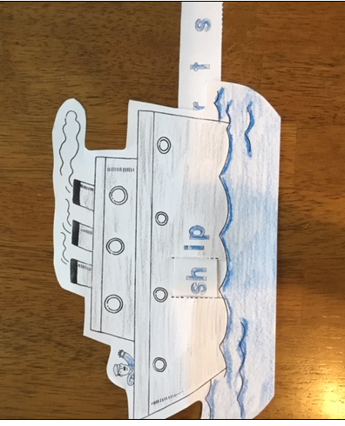

*Science – 1. Hand Washing Patrol – make sure everyone at home is washing. ☺

*Special – Music (check Mrs. Smith’s webpage)

**Friday, April 3**

*Math – 1. Watch “Math On the Spot Video Tutorial” for lesson 6.5

2. lesson 6.5 – pages 335-337, 339-340

*Science – “Washing My Hands” Mini Book, practice reading the book aloud (Can you find some sight words?)

*Special – Phys. Ed. (check Mr. Boronyak’s webpage)

**Extra Practice and Enrichment Options**

*ELA: 1. Rainbow write - choose 5 sight words from the sight word list & practice writing the words with

colored pencils, crayons or markers

1. record yourself reading the decodable, *What Can Two Do?* and email it to me or post it on seesaw-or both

3. FaceTime a relative or friend and read sight words or your decodable

4. check out seesaw – I assigned some activities for you to complete & submit to me

*Math: 1. practice writing your numbers to 30 – use a pencil, crayons, markers, chalk (if it’s nice outside), circle

evens, underline the odds

1. using items in your house, act out subtraction number sentences

(For example: There were 3 thin mints. Mrs. King ate 2. How many are left

1. Go on a shape hunt in your house (or in your yard) can you find a circle, square, triangle, rectangle,

hexagon. Take pictures of what you find and post on seesaw or email them to me.

1. check out seesaw – I assigned some math activities for you to complete & submit to me

*Science – <https://www.youtube.com/watch?v=8YiN4tFVA9E>